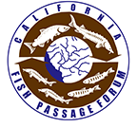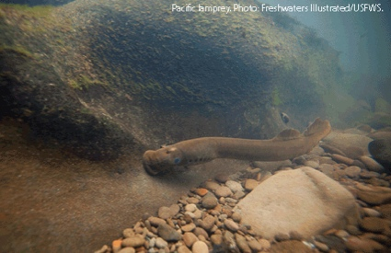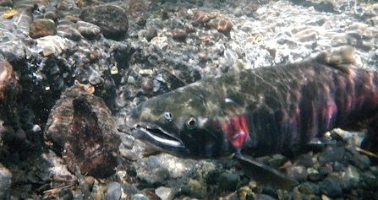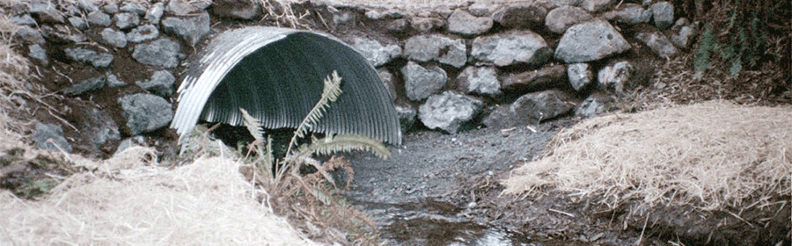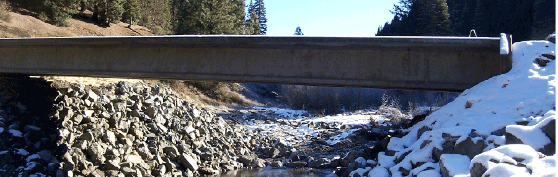

California Anadromous Fish passage strategic Framework 2013-2018



Prepared by the California Fish Passage Forum Fish Habitat Partnership

Table of Contents

Executive Summary 3

Introduction 5

Overview of the Framework 6

Geographic Scope of the California Fish Passage Forum 7

Factors Impacting Anadromous Fish Habitats in California and Identification of Critical Threats 8

Fish Species Impacted by Passage Barriers in California 10

History of the California Fish Passage Forum Fish Habitat Partnership 12

California Fish Passage Forum Fish Habitat Partnership Members 17

The California Fish Passage Forum Fish Habitat Partnership Mission, Goal, and Objectives 19

The California Fish Passage Forum Fish Habitat Partnership Conservation Priorities 21

The California Fish Passage Forum Fish Habitat Partnership Strategic Conservation Actions 26

Recommendations and Guidance for Regional Scale Projects 28

Recommendations and Guidance for Local Scale Projects 29

Climate Change and the California Fish Passage Forum Fish Habitat Partnership 30

Bibliography 31

Appendices 32

Appendix I – Links to California State Wildlife Action Plan and Steelhead Restoration and Management Plan for California 33

Appendix II. California Fish Passage Forum Memorandum of Understanding 36

Appendix III – California Fish Passage Forum Bylaws 37

# Executive Summary

Anadromous fish habitats in California have been detrimentally impacted by human-caused and natural disturbances. Man-made barriers to anadromous fish migration include road-stream crossings, irrigation diversions, dams, and many other in-stream structures. Passage impediments affect adult and juvenile fish by delaying or preventing upstream and downstream migration, preventing the use of available habitat, and possibly inflicting injury or death.

Addressing connectivity has been consistently identified as a high priority, cost-effective approach to protecting and restoring anadromous fish populations. Restoring unimpeded passage for aquatic organisms in anadromous systems is imperative for the success of all other habitat restoration activities. Both state and federal action and recovery plans identify fish passage and connectivity as major limiting factors for listed salmonids in California:

* Numerous State Plans, such as the California State Wildlife Action Plan, identify fish passage and connectivity, as a significant impact on California fisheries, and a high priority for restoration efforts. The Recovery strategy for California Coho Salmon (2004) and the Steelhead Restoration and Management Plan for California (1996), both published by the California Department of Fish and Wildlife, list fish passage as high priority recovery tasks. Specifically, the Recovery Strategy for California Coho Salmon makes a recommendation to “continue and complete assessments and prioritizations for correction of fish passage barriers.”
* NOAA Recovery plans for coho salmon and South Central steelhead identify fish passage barriers as a major limiting factor in recovery of listed salmonids in California. The NOAA Southern California Steelhead Recovery Plan supports the rationale for why fish passage is so important in California. It states, “Re-establishing access to upper watersheds in both small coastal streams and several of the larger river systems within each biogeographic region identified by the TRT is one of the highest priorities in the Southern California Steelhead DPS.”
* In addition, the USFWS has completed recovery plans for Shortnose Sucker and lost river sucker populations, and identifies removing fish passage barriers as a primary action to recover both sucker populations. Pacific lamprey is proposed for listing, and Green Sturgeon have been listed as Threatened, with fish passage barriers identified as a major threat to their population. NOAA’s Open Rivers Initiative is based on the fundamental concept that removing fish passage barriers is a priority action for species recovery, and other fish passage programs at the USFWS and NRCS have also formed around this major limiting factor.

A coordinated and comprehensive fish passage improvement program is fundamental to addressing fish passage barriers. The **California Fish Passage Forum** (Forum), a consortium of federal, state, nonprofit and private sector organizations, was established in response to significant declines in coho salmon, Chinook salmon, and steelhead. At least one population of all of these species are Federally listed as either Threatened or Endangered within California, and efforts are underway to recover their populations. In addition to the salmonid species listed above, the Forum recognizes the significant impacts of passage barriers to Pacific lamprey, white and green sturgeon, Klamath Basin Lost River Sucker, and Shortnose sucker.

The Forum:

* facilitates, advances, and disseminates information related to improving passage of fish species within and beyond the State of California;
* coordinates among agency programs and private sector activities across jurisdictions to target high priority fish passage projects, and to improve the timeliness and cost-effectiveness of fish passage restoration efforts;
* explores opportunities to secure and provide funding for fish passage projects in the anadromous waters of California;
* efficiently identifies and remedies technical and procedural obstacles to fish passage; and
* 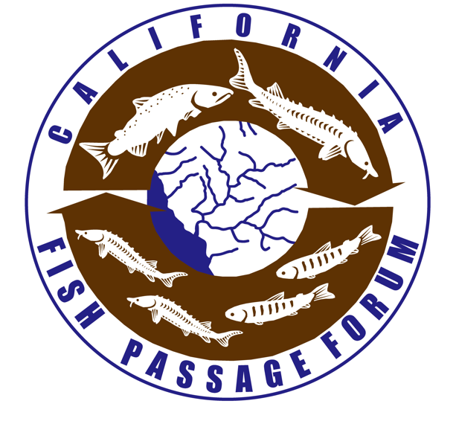serves as an informal advisory body to fish passage improvement efforts outside of anadromous watersheds.

# Introduction

Aquatic habitat in anadromous streams and rivers in California has been subject to substantial change and degradation. Although numerous factors have contributed to the current status of these habitats, loss of connectivity within and among watersheds has been recognized in recovery plans and watershed assessment documents as a significant impediment to recovering anadromous fish throughout the Pacific Northwest. All habitat restoration activities in anadromous watersheds are linked to the ability of migratory aquatic species to access these ecosystems.

Barrier removal or modification is considered to be a cost-effective approach to the short-term recovery of anadromous fish. Man-made barriers to fish passage include road-stream intersections, pipeline or other infrastructure crossings, erosion control/flood control structures (rip-rap, concrete channels, e.g.), and dams that block or delay migration. These barriers impact both adult and juvenile fish by preventing full use of available habitat or altering habitat and hydraulic conditions.

During the late 1990s, Washington, Oregon, and Alaska initiated coordinated statewide fish passage efforts. In November 1999, the California Natural Resources Agency (CNRA) convened a group of interested state, local, and federal agencies, fisheries conservation groups, researchers, restoration contractors, and other interested parties to discuss ways to restore and recover anadromous fish populations by improving fish passage at man-made barriers. This effort was part of CNRA’s effort to implement an eight-point California Coastal Salmon and Watersheds Program. One of the major focal points in this program involves coordinating fish passage activities in the anadromous waters of California, and thus addressing the major limiting factor identified in most recovery plans for listed anadromous fish species. The outcome of the initial convening was the creation of the California Fish Passage Forum (Forum), a collaborative group that works to implement and coordinate fish passage activities across the anadromous waters of the state.

It was recognized that there is a critical need for improving coordination of existing agency programs and private sector activities across jurisdictions to improve the timeliness and cost-effectiveness of fish passage restoration efforts. The Forum recognizes that funding for design, implementation, and monitoring of fish passage projects is often limited and inhibits the number of projects that can be implemented in a timely manner. In an effort to address this issue, the Forum actively seeks ways to coordinate fish passage funding, identify optimal locations to make strategic investments, and foster new or alternative funding sources.

# Overview of the Framework

The development of this Framework incorporates the work of the numerous organizations that comprise the Forum[1]. The Forum is a collaborative effort among state, local and federal agencies, fisheries conservation groups, researchers, restoration contractors, and other interested parties to explore and develop an effective methodology and plan to restore and recover anadromous fish populations by improving fish passage at man-made barriers. The Framework helps to advance California’s State Wildlife Action Plan (SWAP) and Steelhead Restoration and Management Plan (SRMP) (Appendix 1), the numerous other plans that address anadromous fish barriers, and the goals and objectives of the National Fish Habitat Action Plan.

The Framework defines the vision and goals, strategic objectives, conservation priorities, and strategic actions that will guide the future of the Forum, with a focus on facilitating partnerships related to data gathering, information sharing, planning, prioritizing, implementing, and monitoring fish passage efforts.

The Forum will use this Framework as a guide to focus efforts at all scales to advance strategic, efficient, credibly funded, accountable investments in fish passage initiatives in California.

Finally, the Framework will further the Forum’s efforts to coordinate with other conservation and recovery efforts in the western United States. The collaborative nature of the Forum has led to collaboration and cooperation among entities working on fish passage in the anadromous waters of California. The Forum has also contacted fish passage groups from other states and has made contact with the Desert Fish and Western Native Trout Initiative Fish Habitat Partnerships (FHP). The Framework provides a well-defined description of the Forum’s goals, activities, geographic extent, and operating structure that can be shared with these other interested parties.

Male coho salmon (*Oncorhynchus kisutch*). Photo credit: National Park Service.

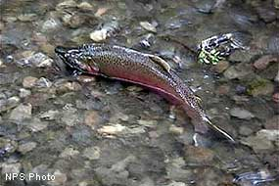

# Geographic Scope of the California Fish Passage Forum

Figure 1. The geographic scope of the Forum encompasses the anadromous waters of California.

# Factors Impacting Anadromous Fish Habitats in California and Identification of Critical Threats

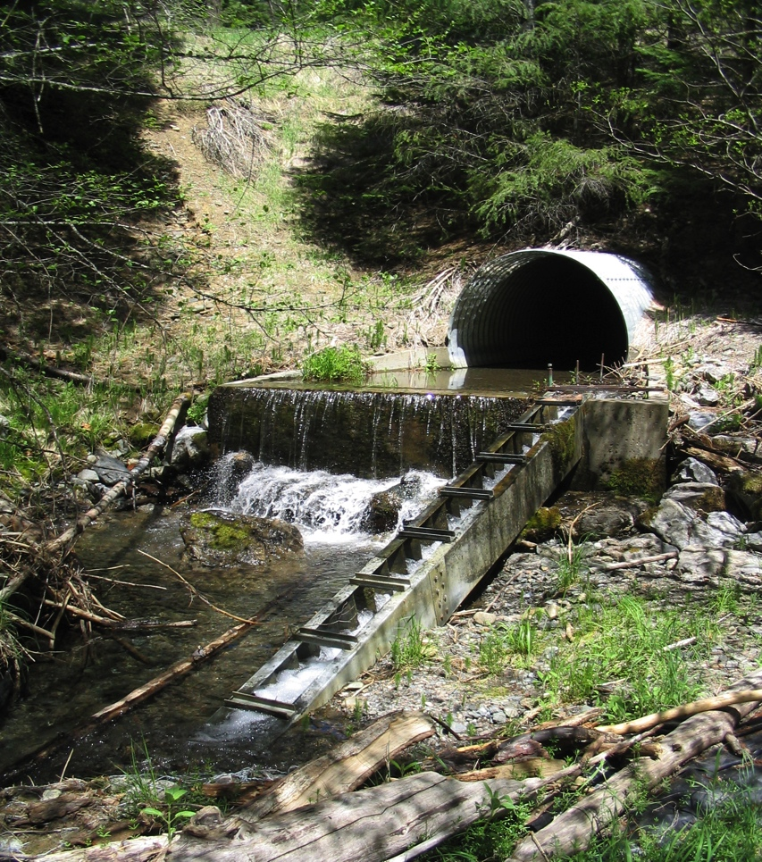Many anadromous aquatic habitats in the western United States have been highly altered from their historic condition. The habitat changes are the result of natural and human-induced stressors, including changes in runoff patterns and water storage, land use and natural resource extraction activities, spatial and temporal changes in connectivity, non-native species introductions, increased predator populations, commercial and recreational fishing, hatchery operations, and natural environmental variations.

To address these and other stressors, habitat restoration activities, many of these locally based and relatively site-specific, have occurred in California and the Pacific Northwest. In addition, regional assessments of restoration needs and prioritization related to anadromous fish and their habitats have occurred. Many of these assessments ranked connectivity as the top priority for strategic regional restoration (Roni et al. 2002, Hooybar 2003) because connectivity focused projects have the highest likelihood of success, are cost effective, show immediate results, are long lasting, and can guide where other restoration activities should be implemented based on restored access to larger areas of habitat.

This photo features an example of a fish barrier on the Shasta-Trinity National Forest. An open-bottom arch composed of natural streambed will remediate this fish passage barrier and improve fish passage for several listed and non-listed fish species. Photo credit: Shasta-Trinity National Forest.

In California, several recent documents related to recovery and management of federally and state listed fish species have also designated fish passage as a high priority.

* The Recovery strategy for California Coho Salmon (2004) and the Steelhead Restoration and Management Plan for California (1996), both published by the California Department of Fish and Wildlife (CDFW), list fish passage as high priority recovery tasks.
* National Oceanic and Atmospheric Administration (NOAA) National Marine Fisheries Service (NMFS) Recovery plans for coho salmon and steelhead identify fish passage barriers as a major limiting factor in recovery of listed salmonids in California. Pacific lamprey is proposed for listing, and Green Sturgeon have been listed as Threatened, with fish passage barriers identified as a major threat to their populations.
* The Open Rivers Initiative (NMFS) and the National Fish Passage Program (USFWS) are based on the fundamental concept that removing fish passage barriers is a priority action for species recovery.
* Other Federal (Natural Resources Conservation Service [NRCS]), state, and regional fish passage programs have been created because of fish passage barriers. The U.S. Fish and Wildlife Service (USFWS) has completed recovery plans for Shortnose Sucker and lost river sucker populations, and identifies removing fish passage barriers as a primary action to recovering both sucker populations.

The Forum recognizes that fish passage is an important issue to numerous aquatic species in anadromous and non-anadromous waters. The Forum also acknowledges the importance of other limiting factors for anadromous fish survival, such as healthy riparian habitat, and water quality and quantity. Many of the Forum Memorandum of Understanding signatories also work to address issues of water quality, quantity, policy and practice modifications, and other forms of in-stream and riparian habitat restoration that will improve the overall anadromous and resident fish populations within the Forum’s geographic scope. The Forum recognizes, through its focus on fish passage issues, that without access to freshwater habitat, other anadromous fish restoration efforts will not succeed.

# Fish Species Impacted by Passage Barriers in California

## Anadromous Species

California streams and rivers with access to the ocean were historically home to several native anadromous fish species. These include Chinook salmon, coho salmon, chum salmon, pink salmon, steelhead/rainbow trout, coastal cutthroat trout, green sturgeon, white sturgeon, pacific lamprey, river lamprey, eulachon, and threespine stickleback. American shad and striped bass are also prevalent non-native anadromous species in many systems.

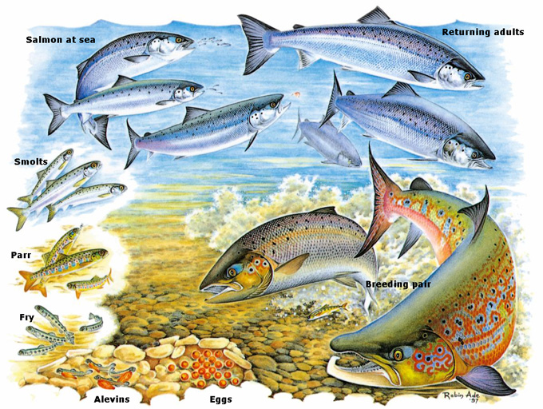Historically, anadromous fish passage efforts in California have focused on Chinook salmon, coho salmon, and steelhead. Pink salmon have only occurred rarely in California since the latter half of the 20th century. Chum salmon are slightly more common than pink salmon, but have a limited presence in California. Coastal cutthroat trout are a State of California Species of Special Concern, but have no federal status and have generally not been the focus of fish passage efforts. Passage impacts on green and white sturgeon are almost exclusively limited to large dams, therefore, passage improvement projects for sturgeon are complex, expensive, and uncommon. Efforts are underway in the Pacific Northwest to analyze and mediate the impact of barriers on lampreys. These efforts are often linked to passage projects associated with salmon and steelhead and once refined, will likely consist mainly of additions or alterations to traditional salmonid passage designs. Passage does not likely have a major impact on eulachon as they are found in the lower reaches of coastal rivers and streams and spend very little time in freshwater. Threespine sticklebacks are very adaptable and demonstrate a wide variety of life history strategies that likely greatly reduce the impact of barriers.

The life cycle of anadromous salmonid species. Artwork credit: Robin Ade.

## Other Species

California has a limited number of federally listed fish species or fish species included in the State Wildlife Action Plan that occur in anadromous waters. Delta smelt are listed as threatened under the federal and California Endangered Species Acts (ESAs). Longfin Smelt are listed as threatened under the California ESA, but are not listed federally. Both delta and longfin smelt have been subjected to degradation of their native habitat and environment, however passage is not considered an important factor in the declines of these species.

Shortnose suckers are listed as endangered under the federal and California ESAs. Klamath largerscale suckers are included in the SWAP but are not listed under the federal or California ESA. Both of these sucker species are uncommon in the anadromous reach of the Klamath River.

The Forum will continue to focus on fish passage assessment, prioritization, and implementation for salmonids and lamprey. Additionally, the Forum will consider actions to address other anadromous and resident species in anadromous watersheds as the need arises and cost-effective passage methods are developed.

# History of the California Fish Passage Forum Fish Habitat Partnership

California’s historically bountiful anadromous fishery depends on the ecological integrity of dozens of streams and rivers that flow into the Pacific Ocean along the state’s 1,100-mile coastline. These streams provide the habitat that salmonids and other anadromous fish require during the spawning and juvenile phases of their life.

During the 19th and 20th centuries, as roads, bridges, and dams were built on public and private lands along waterways, and as water was diverted by various means, thousands of barriers were erected, blocking the passage of anadromous fish. These barriers impact both adult and juvenile fish by preventing full use of available habitat or altering habitat and hydraulic conditions. Consequently, many salmon, steelhead, cutthroat trout, lamprey, and sturgeon populations have experienced significant declines, and the sport and commercial fisheries that depended on some of these populations have, in many cases, vanished.

Man-made barriers to fish passage include road/stream intersections, pipeline or other infrastructure crossings, erosion control/flood control structures (rip-rap, concrete channels, e.g.), and dams that block or delay migration. In some cases, previously installed fish passage structures, such as fish ladders, act as barriers because of poor design or construction as well as lack of maintenance.

In October 1999, the California Resources Agency established the eight-point California Coastal Salmon and Watersheds Program, which called for the coordination of State, federal, and local partners working toward the goal of restoring salmon and steelhead populations to naturally sustainable levels. At the time, fish passage was recognized as a major threat to anadromous fish species in California that could potentially yield the greatest cost-efficiency for short-term restoration activities. Based on this recognition, the program included an objective to coordinate fish passage activities in California.

To accomplish this objective, the California Natural Resources Agency (CNRA) convened a group of interested state, local and federal agencies, fisheries conservation groups, researchers, restoration contractors and others to discuss ways to improve fish passage at man-made barriers. The success of this coordination led to the establishment of the California Fish Passage Forum, of which many agencies and organizations are members.

The Forum identified the need for improved efforts to identify barriers, evaluate and prioritize restoration opportunities, and implement projects in a timely fashion. It also targeted administrative, financial and technical impediments to addressing these issues, including information gaps, lack of watershed-level assessment and planning, and poorly coordinated project review and permitting processes. Forum participants worked together to develop short-term solutions for these types of problems for several known high priority fish passage projects. They also established subcommittees for coordinating activities related to fish passage inventory and assessment protocols, data format and access protocols, information and literature collection, permitting, training, and public education and outreach.

The Forum’s first step in charting a course for restoring passage for California anadromous fish was to determine the quantity and severity of existing migration barriers. In collaboration with the California Coastal Conservancy and the Pacific States Marine Fisheries Commission, the Forum developed the Passage Assessment Database (PAD). The PADis an ongoing map-based inventory of known and potential barriers to anadromous fish in California, compiled and maintained through a cooperative interagency agreement. The PAD compiles currently available fish passage information from many different sources, allows past and future barrier assessments to be standardized and stored in one place, and enables the analysis of cumulative effects of passage barriers in the context of overall watershed health.

The PAD database identifies and compiles information on more than 16,000 potential barriers to fish passage in California’s coastal and Central Valley watersheds (Figure 2 - Source: CalFish Passage Assessment Database [http://www.calfish.org]). Of the structures that are of human origin, at least 1,500 are severe or impassable.

*Includes non-structural (waterfall, grade, temperature, insufficient flow, landslide, velocity, etc.) and log jams.   
**Includes flood control channels, grade control, flow measurement weir, gravel/borrow pits, tide gates, fish traps and other barrier types.   
***Includes road (culvert, bridge, low-flow, etc.) and utility crossings.   
For barrier type descriptions, see: http://www.calfish.org/portals/0/Programs/FishPassage/PADMethodology_February2013.pdf

Correlated with state and federal recovery plans for endangered coho salmon, the PAD is a valuable prioritization tool that allows the Forum to target high priority fish passage barriers in critical watersheds.

The database is designed to capture basic information about each potential barrier. It is designed to be flexible; as the database grows, other modules may be added to increase data detail and complexity. The PAD also makes it possible for Forum members to track project implementation and quantify the amount of habitat made accessible (Figures 3 and 4).

*Includes non-structural (waterfall, grade, temperature, insufficient flow, landslide, velocity, etc.) and log jams.   
**Includes flood control channels, grade control, flow measurement weir, gravel/borrow pits, tide gates, fish traps and other barrier types.   
***Includes road (culvert, bridge, low-flow, etc.) and utility crossings.   
For barrier type descriptions, see: <http://www.calfish.org/portals/0/Programs/FishPassage/PADMethodology_February2013.pdf>

Note: This table excludes all projects where the year the restoration work occurred was unknown. It combines completed projects and completed projects that need monitoring.

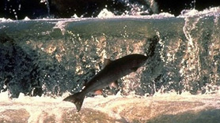

Salmon and other migrating fish, such as sturgeon, need access to freshwater habitat for spawning and rearing their young. Some fish need to swim thousands of miles through oceans and rivers to reach their destination. Unfortunately, that journey is often blocked by man-made barriers that exist in many rivers and streams across the country. Photo credit: NOAA.

*Includes non-structural (waterfall, grade, temperature, insufficient flow, landslide, velocity, etc.) and log jams.   
**Includes flood control channels, grade control, flow measurement weir, gravel/borrow pits, tide gates, fish traps and other barrier types.   
***Includes road (culvert, bridge, low-flow, etc.) and utility crossings.   
For barrier type descriptions, see: <http://www.calfish.org/portals/0/Programs/FishPassage/PADMethodology_February2013.pdf>

Note: Miles opened values are derived from the miles upstream (i.e., miles to limit of anadromy). In absence of values in this field, the miles opened values come from miles to next barrier in the PAD. This table excludes all projects where the year the restoration work occurred was unknown. It combines completed projects and completed projects that need monitoring.

# 

Figure 4. Fish barriers documented in the Passage Assessement Database as of April 1, 2013.

# California Fish Passage Forum Fish Habitat Partnership Members

The organization of the Forum is based on a Memorandum of Understanding (MOU; Appendix II), through which Forum signatories commit to developing and implementing cooperative strategies aimed at restoring fish access to spawning and rearing habitat. The MOU formally recognizes the Forum’s voluntary collaboration and provides mutually agreed upon guidance through its stated goals and objectives. The MOU also confirms the intent of state and federal fishery resource agencies and other interested parties to participate in and support Forum activities

Forum members represent a diverse group of agencies and entities with a common interest in fish habitat restoration and fisheries recovery in the state of California. MOU signatory members include:

* Federal agencies
  + US Fish and Wildlife Service (USFWS)
  + NOAA National Marine Fisheries Service (NMFS)
  + US Forest Service (USFS)
  + US Army Corps of Engineers (ACOE)
* State agencies
  + California Natural Resources Agency (CNRA)
  + California Department of Fish and Wildlife (CDFW)
  + California Department of Water Resources (DWR)
  + California Department of Transportation (Cal Trans)

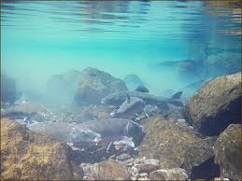

Shortnose suckers are large, long-lived, and late-maturing fishes. Most adults do not begin to spawn until five or six years of age and many may live up to 40 years. They spend the majority of their lives in lakes, but migrate upstream in tributaries to spawn. Fry move downstream after hatching where they occupy shallow water, moving into deeper water as they mature. Photo credit: Conservationonline.org.

* + State Coastal Conservancy
* Local government organizations
  + Five Counties Salmonid Conservation Program
* Nonprofit organizations
  + California Trout
* An interstate marine fisheries commission
  + Pacific States Marine Fisheries Commission (PSMFC)

The Forum focuses on four distinct regions in California, each with its own anadromous fish population characteristics, challenges, and issues: the North Coast, Central Coast, South Coast, and Central Valley regions. These regions also contain other species of interest that are considered in Forum activities. Although the state and federal MOU signatory members have jurisdictions across all of these regions, the additional Forum members and partners vary in each region based on their specific jurisdictions and levels of involvement.

Although Forum members develop unique prioritization lists and treatment prescriptions in each of the four distinct California regions, the Forum develops standardized data management systems, assessment protocols, design manuals and outreach programs that cover the full geographic extent of the Forum and address the Forum’s strategic planning process.

The Forum meets quarterly in different locations in California. During the meetings, issues are resolved, decisions made and strategic topics discussed. Members also form smaller, focused working groups and committees in which specific goals and tasks are addressed. The Forum’s bylaws, which govern the membership and decision-making process, are included in Appendix III.

Parties that have not signed the MOU may participate in Forum activities and attend regular Forum meetings. These members represent local communities and organizations, landowners and utility owners, land and water districts, and others. Though not signatories, these members are an important component of the partnership, and their contributions, in terms of experience and expertise, are important to achieving the Forum’s objectives.

|  |  |  |  |  |
| --- | --- | --- | --- | --- |
|  |  |  |  |  |
|  |  |  |  |  |
|  |  |  |  |  |

# The California Fish Passage Forum Fish Habitat Partnership Mission, Goal, and Objectives

## Mission

To protect and revitalize anadromous fish populations in California by restoring connectivity of freshwater habitats throughout their historic range.

## Goal

Restore the connectivity of freshwater habitats throughout the historic range of anadromous fish.

To achieve the mission and goal, the California Fish Passage Forum will:

* Improve coordination of existing agency programs, rule and guideline efforts, and private sector activities across jurisdictions to improve the timeliness and cost-effectiveness of fish passage restoration efforts.
* Facilitate collaboration, coordination, and communication among state, federal and local agencies, researchers, restoration contractors, landowners and other interested stakeholders on fish passage improvement programs and projects.
* Expedite implementation of on-the-ground projects by identifying and addressing institutional barriers.
* Educate and increase the public and agency awareness of fish passage issues to develop support for solving problems and preventing new ones.
* Seek additional funding sources for fish passage projects within the geographic scope of the Forum and administer a strategic funding program for projects once funding is secured.

## Objectives

1. Facilitate coordination and communication among agencies, agency staff, and other entities that may propose, review, or promulgate fish passage criteria within California.
2. Identify, assess and prioritize fish passage barriers on public lands and to the extent practical or consistent with landowner goals, private lands.
3. Disseminate guidelines and design criteria for replacement of barriers.
4. Coordinate funding mechanisms to remove fish passage barriers.
5. Promote State and Federal permit coordination and streamlining.
6. Facilitate plans to monitor and evaluate fish passage restoration effectiveness to ensure accountability.
7. Work to promote state and national policy that supports fish passage.
8. Implement education and outreach activities, targeting both the general public and fish passage practitioners.

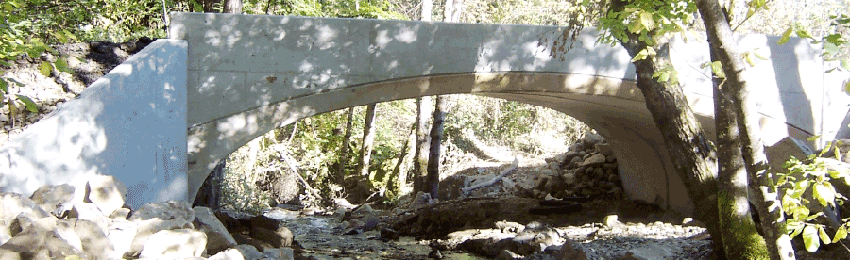

The Conner Creek Project will provide full passage for all life stages of coho salmon and steelhead by removing two culverts. Conner Creek flows directly into the Trinity River, a tributary of the Klamath River. Photo credit: Caltrout.org.

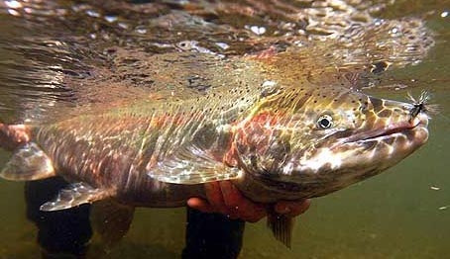

California Steelhead. Photo credit: Caltrout.org

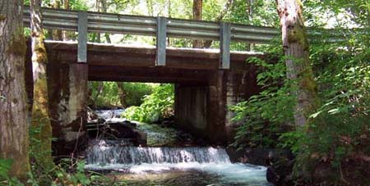

“Before” view of Conner Creek at Conner Creek Road prior to removal of the two culverts.   
Photo credit: Caltrout.org

# The California Fish Passage Forum Fish Habitat Partnership Conservation Priorities

The Forum’s conservation priorities and objectives are based on the goal of restoring and protecting healthy anadromous fish populations by restoring habitat connectivity. The following objectives and numeric targets are proposed for 2013–2018, and will be used by the California Fish Passage Forum to measure the success of implementing this framework. These objectives and numeric targets may be modified by Forum members through the annual work planning process. Throughout the five-year period, the Forum will review its progress and update this framework.

Regular meetings and communication are the foundation for accomplishing the Forum’s objectives, the Forum will convene up to four times annually to share project priorities, reviews, and treatment status reports, as well as determine priorities for Forum efforts.

The meetings also provide a venue for identifying additional anadromous habitat restoration opportunities throughout California and allow for agency cooperation during the project design, permitting, and implementation phases. The Forum will expedite implementation of on-the-ground projects by promoting and facilitating cost-sharing, technical assistance, and networking. Distribution of meeting minutes and other important documents will enhance participation by all Forum members.

### Objective 1: Facilitate coordination and communication among agencies, agency staff, and other entities that may propose, review, or promulgate fish passage criteria within California.

1. Assure that emerging national, interstate and state fish passage related design standards and guidelines are brought to the attention of the Forum members in a timely manner.
2. Conduct outreach to federal agencies that may develop passage criteria, regulations, or guidelines to include the Forum in scoping, comments, and other public/agency coordination. Agencies contacted should include, but not be limited to all Forum federal agencies as well as the Federal Highway Administration (FHWA), US Department of Agriculture-Natural Resources Conservation Service (NRCS), and Federal Emergency Management Agency (FEMA).
3. Conduct outreach to state agencies that may develop passage criteria, regulations, or guidelines to include the Forum in scoping, comments, and other public/agency coordination. Agencies contacted should include all Forum state agencies as well as State Parks, CalFire and Office of Emergency Services.

### Objective 2: Continue to identify, assess and prioritize fish passage barriers on public lands and where appropriate, private lands.

1. Facilitate the use of the statewide fish passage barrier inventory, the Passage Assessment Database (PAD), and continue to populate it with new data.
   1. Outline funding sources for maintenance of the PAD through 2017.
   2. Support and guide enhancements of the PAD including online applications of data analysis and reporting, and a document library.
   3. Annually report barrier data and project status updates to the PAD.
   4. Assist with continued public access to the PAD data via the CalFish website including regular (quarterly) releases of the PAD.
2. Develop and communicate consistent protocols for prioritizing fish passage restoration at barriers.
   1. Develop statewide methods for biological prioritization (first-tier) of barriers by June 2012.
   2. Develop second-tier parameters for barrier prioritization to account for regional and institutional specifics.
   3. Publish an annual report of statewide barrier priorities.
3. Coordinate with state agencies to develop a list of priority fish passage projects for California.
   1. Coordinate with CDFW to publish an annual report of statewide barrier priorities by June 2012.
   2. Coordinate with Caltrans to identify and publish transportation barrier priorities by September 2012.
4. Identify gaps in watershed and barrier information using the PAD and other resources and develop a plan to fill those gaps. The Forum will continue to work with its members to coordinate funding and staff for inventories. If warranted, the Forum will convene an Assessment Working Group to help standardize methods and coordinate funding.
   1. Annually publish a report identifying remaining data gaps in the PAD and priorities for barrier inventories and fish passage assessment.
   2. In watersheds where insufficient barrier data exist, identify and contact entities involved in field data collection and solicit barrier inventories and passage assessments.
   3. Work with willing private landowners to identify and inventory potential barrier sites.
   4. Distribute data collection protocols and methodologies to ensure standardized approaches to data collection.

### Objective 3: Disseminate guidelines and design criteria for replacement of barriers.

1. Coordinate training workshops throughout the state on the fish passage design and implementation criteria, as needed.
2. Protect access to existing fish habitat by insuring that new infrastructure crossings are designed and constructed according to proper aquatic organism passage criteria as developed through the Forum and agency rule making processes. Assure that new crossings comply with Endangered Species Act requirements.
3. Assure that replacement crossings funded under OES and FEMA comply with Endangered Species Act requirements. Continue to work with FEMA and OES on addressing the replacement criteria in the event of designated emergencies.

### Objective 4: Develop project cost guidelines and coordinate and acquire funding to remove 5 to 15 fish passage barriers per year.

1. Work with project managers, grant recipients, agencies and others to develop a database of cost information for repair and replacement activities.
   1. Design a Passage Project Cost Database including a minimum set of data fields and ensure data compatibility and easy data transfer with existing related databases.
   2. Identify sources of relevant information for fish passage project cost including details for all phases of fish passage project (design, permitting, construction) typical for California.
   3. Continue data compilation into the Cost Database.
2. Seek additional funding sources for fish passage projects within the geographic scope of the Forum and administer a strategic funding program for projects once funding is secured
   1. Depending on funding levels, address 5–15 barriers per year.
   2. The Forum will use the PAD, the expertise of Forum members, potential funding from other sources, and the passage criteria provided by the CDFG and NMFS to strategically fund high priority projects.

### Objective 5: Promote project permit coordination and streamlining.

1. Identify opportunities for improved inter-agency cooperation and permit streamlining.
2. Assist in continued support of programmatic and regional permitting for fish passage projects. The Forum will continue to work to solve problems with permitting through the Permitting Working Group.

### Objective 6: Facilitate plans to monitor and evaluate fish passage restoration effectiveness to ensure accountability.

1. Establish mechanisms to monitor and ensure that projects are appropriately designed and implemented by working with CDFG’s California Monitoring Plan.
2. Establish mechanisms or programs to evaluate changes in habitat use that result from fish passage improvement projects.
3. Establish ways to estimate or quantify population increases that result from fish passage projects and to predict increases from proposed projects. The Forum will work with the state and federal agencies and others to gather reporting information and data that document population and habitat changes. A working group will help to coordinate this effort and report back to the larger group.

### Objective 7: Work to promote state and national policy that supports fish passage.

1. Coordinate with other Western States to share ideas and promote fish passage policy and efforts. The Forum will work to facilitate joint meetings with other Pacific States.
   1. Propose an inter-state Fish Passage Workshop for California, Oregon and Washington every other year starting in 2013 to discuss fish passage issues with national relevance. (Current topics include Transportation Enhancement Funds, FEMA and NFHP).
2. Work with the National Fish Habitat Action Plan program to develop national policies that support fish passage through federal programs (FEMA, Transportation Enhancement Act).

### Objective 8: Implement education and outreach, targeting both the general public and fish passage practitioners.

1. Support development and implementation of effective education and outreach programs to engage and inform the public and private landowners about aquatic habitat fragmentation and fish passage improvement opportunities.
2. Create and distribute fish passage outreach material such as the ‘Fish Passage Success Stories’ DVD and the Fish Passage Forum brochure which both succinctly demonstrate fish passage issues in California and the Forum’s history and purpose. Additional outreach material would be developed and distributed as needed.
3. Communicate fish restoration activities to other agencies, landowners, watershed groups and others within each basin.
4. Implement workshops to train local agency field crews or other interested groups to properly conduct fish passage evaluations.
   1. The Education Working Group will coordinate all of the above efforts and assist entities in training and public outreach where needed. This group will also help coordinate funding where possible and serve as a source for making recommendations to the larger group.

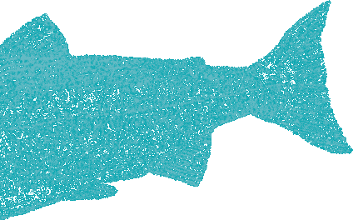

Art credit: University of Washington.

# The California Fish Passage Forum Fish Habitat Partnership Strategic Conservation Actions

Local scale Forum projects have addressed, and will continue to address, the following tasks. Continued implementation of these tasks in local scale conservation projects will help ensure project effectiveness and will also support the goals and objectives set forth by the California Fish Passage Forum Partnership.

1. Identify Passage Barriers, Opportunities for Removal and Priorities for Implementing Projects
   1. Continue to assess the health of the anadromous watersheds, including identifying and mapping fish passage barriers across ownerships within watersheds in order to identify limiting factors for anadromous fish and to prioritize habitat restoration investments.
   2. Identify and fill gaps in the barrier inventory and prioritization data.
   3. Utilize existing local inventory and prioritization (Caltrans, County) and regional prioritization (PAD) data to develop barrier removal projects.
   4. Update the PAD when projects are completed.
2. Seek additional funding sources for fish passage projects within the geographic scope of the Forum and administer a strategic funding program for projects once funding is secured
   1. Depending on funding levels, address 5–15 barriers per year.
3. Ensure that New Structures are Properly Designed to Ensure Fish Passage for Targeted Species and Age Classes.
   1. Disseminate 2001 and 2002 fish passage guidelines from the National Marine Fisheries Service and California Department of Fish and Wildlife to engineering staff.
   2. Coordinate fish passage design and engineering trainings for interested state, federal, local agency and private sector personnel.
4. Incorporate adaptive management practices in project design and implementation to inform and evaluate project techniques and strategies as new information is acquired.
5. Monitor Implementation and Effectiveness of Projects
   1. Use currently available information to establish baseline data for affected habitats and species in the project area;
   2. Develop a habitat based project plan for each project using physical and biological data and watershed fea­tures;
   3. Develop criteria for long-term project monitoring protocols with the objectives of estimating changes in target population status and trends over time;
   4. Track project costs, partner contributions, and other results that will help determine the net benefit to the species and associated aquatic habitats.
6. Utilize Best Management Practices when Implementing Fish Passage and Habitat Improvement and Restoration Projects
   1. Prevent and minimize the movement of sediment and chemical contaminants when implementing project work.
   2. Prevent the movement and introduction of non-native animal and/or plant species into or from project habitats.
   3. 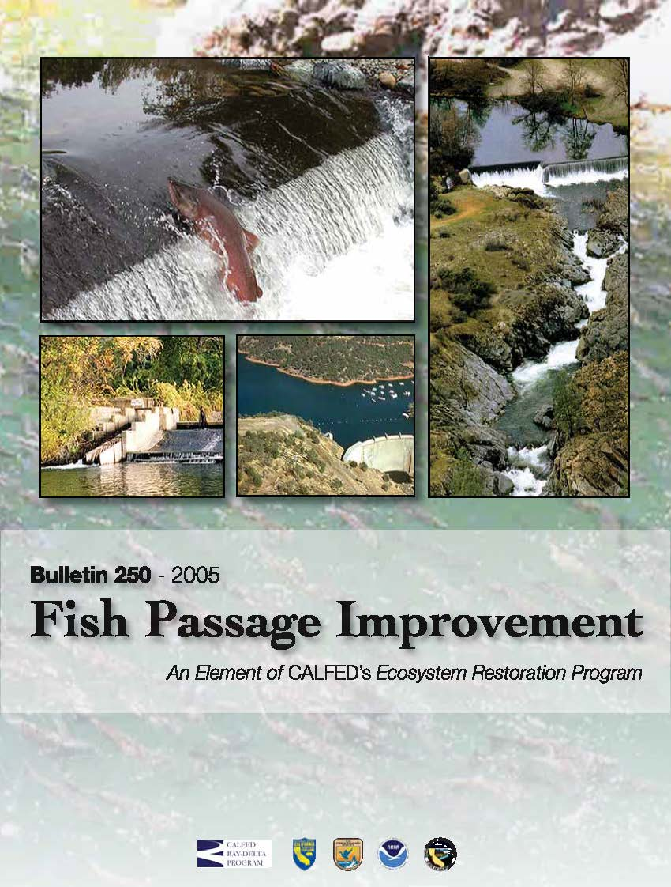Utilize the techniques and recommendations in the California Stream Habitat Restoration Manual (California Department of Fish and Wildlife); the Five Counties Salmonid Conservation, and FishNet 4C Program’s Roads Maintenance Manuals; the 2001 and 2002 Guidelines for Stream Crossings (National Marine Fisheries Service and CDFG); and other applicable state and federal jurisdictional restoration and Best Management Practice guides.

# Recommendations and Guidance for Regional Scale Projects

On a regional scale, the Forum will continue to implement and further develop the following tasks:

* Facilitate coordination and communication among Forum members.
* Improve the State’s ability to implement fish passage restoration projects by coordinating agency and private sector efforts.
* Coordinate and secure adequate funding for fish passage restoration.
* Expedite implementation of on-the-ground projects by coordinating, and, where possible, streamlining agency permitting processes while ensuring that restoration programs comply with the State and/or Federal Endangered Species Act requirements for protecting listed species and any other applicable state or federal laws.
* Facilitate regional plans to monitor and evaluate fish passage restoration effectiveness to ensure accountability.
* Work to promote state and national policy that supports fish passage.
* Implement education and outreach, targeting both the general public and fish passage practitioners to develop support for solving problems and preventing new ones.

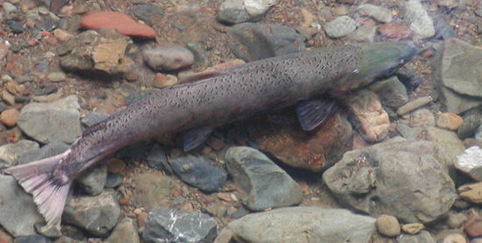

Adult coho salmon in Redwood Creek. Photo credit: National Park Service.

# Recommendations and Guidance for Local Scale Projects

At the local scale, The California Fish Passage Forum will provide guidance and assistance to partners as they identify and implement restoration projects and activities to maintain, restore, or enhance habitat for anadromous fish species.

* Improve and Maintain Habitat Quality and Quantity
  + Establish comprehensive strategies to prevent the loss or reduced quality of habitat for anadromous fish by removing passage barriers.
  + Promote additional habitat improvements that complement restored connectivity, including, but not limited to restoration of natural flow and temperature regimes, coarse sediment supply, physical channel and structural habitat restoration such as reconstructing natural meander patterns, addition of large woody debris, and non-native species control.
* Enhance and/or Restore Connectivity beyond the Removal of Manmade Passage Barriers
  + Identify and implement strategies to minimize and mitigate the negative effects of water development projects to connectivity.
  + Identify existing in-stream modifications (past mining activity) that may inhibit movements and develop strategies and projects to mitigate or remove elements that contribute to habitat fragmentation.
* Prevent and/or Control Non-native and Invasive Aquatic and Vegetative Species while Implementing Barrier Removal Projects
  + Develop strategies for control or management of invasive aquatic/vegetative species that may threaten the continued existence of anadromous fish and healthy riparian area habitat (*Arundo donax* (Giant reed) control).
  + Strategies include but are not limited to, mechanical or chemical removal, replanting of native vegetation, and post-project monitoring and re-treatment.

# Climate Change and the California Fish Passage Forum Fish Habitat Partnership

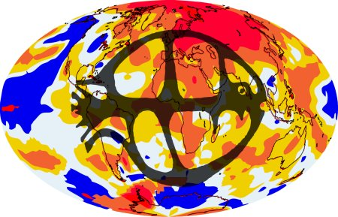Climate change will affect anadromous fish populations, and the prioritization, design, and implementation of fish passage projects will need to adjust accordingly. For example, fish passage projects will have to be designed to accommodate changing flow regimes. Although overall stream flows may decrease in California due to the drier conditions projected to accompany climate change, there may be higher peak flows in the winter, as the majority of precipitation falls as rain rather than snow. Fish passage project prioritization may need to focus on watersheds that are more resilient to climate change, while other watersheds may drop off the list completely as listed species shift their range to avoid increasing temperatures. In addition, sea level rise could shift priorities to barriers higher in the watershed.

Increased connectivity, to facilitate the movement of organisms as they respond to climate change, is recognized as a valuable strategy in restoration projects. Continuing to place high priority on fish passage projects that create connectivity to habitat with an intact flow regime and intact riparian vegetation (to maintain cooler water temperatures) may also be the best strategy in the face of climate change.

# Bibliography

Bunn, D., A. Mummert, M. Hoshovsky, K. Gilardi, and S. Shanks. 2007. California Wildlife: Conservation Challenges, California’s Wildlife Action Plan. Prepared by the Wildlife Health Center, School of Veterinary Medicine, Univ. Calif. Davis for the California Department of Fish and Game, http://www.dfg.ca.gov/wildlife/WAP/report.html.

CDFG. 1996. Steelhead Restoration and Management Plan for California. 1996. California Department of Fish and Game.

CDFG. 2004. Recovery Strategy for California Coho Salmon. California Department of Fish and Game, Species Recovery Strategy 2004-1.

Hoobyar, P. 2003 Restoration priorities for the Hood and Lower Columbia Basins.

Oregon Watershed Enhancement Board Prioritization Framework.

Roni, P., T. J. Beechie, R. E. Bilby, F. E. Leonetti, M. M. Pollock, and G. R. Pess. 2002. A Review of Stream Restoration Techniques and a Hierarchical Strategy for Prioritizing Restoration in Pacific Northwest Watersheds. North American Journal of Fisheries Management 22(1): 1-20.

# Appendices

**Appendix I. Links to California State Wildlife Action Plan and Steelhead Restoration and Management Plan for California.**

**Appendix II. California Fish Passage Forum Memorandum of Understanding.**

**Appendix III. California Fish Passage Forum Bylaws.**

# Appendix I – Links to California State Wildlife Action Plan and Steelhead Restoration and Management Plan for California

The Forum addresses problems and issues associated with fish passage throughout the state, however, four areas receive the majority of the Forum’s focus and are primary regions listed in the California State Wildlife Action Plan (SWAP). These are the North Coast-Klamath, the Central Coast, the South Coast, and the Central Valley-Bay Delta Region.

The majority of California’s river segments with state or federal Wild and Scenic River designations are in the North Coast–Klamath Region, including portions of the Klamath, Trinity, Smith, Scott, Salmon, Van Duzen, and Eel. Anadromous fish species include coho and Chinook salmon, steelhead, coast cutthroat trout, green sturgeon, and Pacific lamprey. The region has experienced significant declines in its fish populations, with an 80 percent decline in salmon and steelhead between the 1950s and 1990s (California State Lands Commission 1993).

On page 261 and 262 of SWAP are “Conservation Actions to Restore and Preserve Wildlife.” Action “b” states,

“Federal, state, and local agencies and private landowners should work to restore fish passage in aquatic systems important for anadromous and wide-ranging fish populations. Efforts to restore fish passage will require cooperative efforts by private owners of dams and water supply companies and partnerships among a wide range of agencies, including such state and local agencies as the State Water Resources Control Board, Caltrans, local water districts, city and county public works departments, and Fish and Game; federal agencies, such as NOAA (National Oceanic and Atmospheric Administration) Fisheries and the Federal Energy Regulatory Commission; other stakeholders, such as Native American tribes; and nongovernmental organizations, land trusts, and watershed councils.

Agencies and partners should continue to update and maintain the Coastal Conservancy’s database (PAD)of barriers to fish passage and use the database to seek and prioritize opportunities to implement fish passage improvement projects. (A link to the database is available at http://www.calfish.org, under the sidebar heading, Fish Passage Assessment.)

Where feasible, fish barriers should be removed or modified. Fish ladders or other means of passage around dams, small-scale diversions, and other impediments should be installed (CDFG 2004g).”

In the Central Coast, the SWAP describes fish passage as a stressor to anadromous fish (Pages 216 and 217).

“Dams and smaller structures such as road crossings can fragment watersheds. As shown above, more than 70 dams and roads create complete barriers to fish passage." "Other artificial structures, such as culverts, low-water road crossings, pipeline crossings, and bridges, also block migration, stream flows, and sediment transport.”

Page 228 of SWAP lists “Conservation Actions to Restore and Preserve Wildlife.” Action “f” provides guidance for the Central Coast:

“Federal, state, and local agencies should work to restore fish passage in aquatic systems important for anadromous and wide-ranging fish populations. Efforts to restore fish passage may require multi-agency partnerships involving such state and local agencies as the State Water Resources Control Board, Caltrans, local water districts, city and county public works departments, and Fish and Game; federal agencies, such as NOAA (National Oceanic and Atmospheric Administration) Fisheries, the National Marine Fisheries Service, and the Federal Energy Regulatory Commission; and nongovernmental organizations, such as Trout Unlimited, land trusts, and watershed councils. The cooperation of private owners of dams and water supply companies will also be needed.”

Actions recommended in the SWAP include:

* Continue to inventory and assess barriers to fish passage, update and maintain the Coastal Conservancy’s database of barriers, and use the database to prioritize and seek opportunities to implement fish passage improvement projects (CDFG 2004g). The Coastal Conservancy’s database is available at http://www.calfish.org, under the Fish Passage Assessment link.
* Where possible, remove or modify structures and barriers to allow passage. Install fish ladders or other means of passage around dams, diversions, and other impediments, including road crossings, pipelines, and culverts. Monitor fish-passage improvement projects to assess benefits to fish populations and to document lessons learned."

In the South Coast Region, the SWAP also references the decline of anadromous fish and the need for improving connectivity of their habitat. On page 175:

“Steelhead illustrate the severity of the situation, having declined from historical populations in the tens of thousands to current numbers of between 200 and 300 fish (CCC 2001, Larson 2005 pers. comm.). Historically, greater connectivity between watersheds allowed species to recolonize after sedimentation events. Today, however, roads and water diversions have fragmented and isolated stream systems, making it difficult for species to recolonize areas where they have been locally extirpated.”

The “Conservation Actions to Restore and Preserve Wildlife,” (page 188 of the SWAP), Action “f” notes:

“Because of the high level of urbanization in the South Coast Region, even the most intact systems will typically need some restoration work. Important restoration actions include enhancing riparian habitat and vegetation; relocating or removing confining levees to allow river-channel meandering and reconnection of rivers with their floodplains; removing dams, diversions, or other obstacles to sediment transport and fish passage…”

The “Steelhead Restoration and Management Plan for California” (SRMP) (DFG 1996), notes, “The major factor causing the decline in California is freshwater habitat loss and degradation. This has resulted mainly from three factors: inadequate stream flows, blocked access to historic spawning and rearing areas...” (Executive Summary, page 1).

Recommendations for restoration under "Instream Habitat" on page 74 of the SRMP says that "Habitat restoration projects that attempt to 1) correct problems created by watershed damage or 2) restore access to historic habitats through barrier modification or removal should receive the highest priority for funding.”

In 2003, California Fish and Wildlife completed the Recovery Strategy for California Coho Salmon. The recovery strategy’s recommendations include planning and regulating water supply development and water rights to ensure adequate stream-flow levels and timing; elimination of barriers to fish passage where possible; and restoration and land management practices that improve habitat conditions. The recovery strategy also provides specific recommendations for individual watersheds and rivers, prioritizes watersheds according to restoration and management potential, and prioritizes the tasks needed to achieve the plan’s goals. Restoring fish passage is a high priority in most watershed recommendations.

# Appendix II. California Fish Passage Forum Memorandum of Understanding

# Appendix III – California Fish Passage Forum Bylaws

## ARTICLE I. NAME, PURPOSE and GEOGRAPHIC AREA

*Section 1 – Name*: The name of the organization shall be the California Fish Passage Forum (Forum).

*Section 2 – Purpose:* The mission of the Fish Passage Forum is to protect and restore listed anadromous salmonid species, and other aquatic organisms, in California by promoting the collaboration among public and private sectors for fish passage improvement projects and programs. These purposes are exclusively scientific and educational and consist of the following objectives:

a. Through voluntary collaboration, education, communication, and advocacy, the Forum is committed to ecological restoration and ecologically sensitive management of ecosystems in the territory defined in Section 3 of this Article. The Forum is committed to applying science based adaptive management practices. The Forum’s main goal is to protect, restore and enhance processes within watersheds (and ecosystems therein) required to preserve, enhance and restore connectivity, structure, functionality, and diversity. The Forum will only take actions that provide a net benefit to native species. Ecological restoration is the process of intentionally altering a site to establish a defined, indigenous, historic ecosystem. The goal of this process is to emulate the structure, function, diversity, and dynamics of the specified ecosystem.

b. The Forum is committed to restoring hydrological and ecological connectivity within anadromous fish habitat wherever possible.

c. To do any lawful activities which may be necessary, useful, or desirable for the furtherance, accomplishment, fostering, or attainment of the foregoing purposes, either directly or indirectly and either alone or in conjunction or cooperation with others, whether such others be persons or organizations or any kind or nature, such as corporations, firms, associations, trusts, institutions, foundations, or governmental bureaus, departments, or agencies.

d. The organization shall act in a manner consistent with, but not limited by, the By-laws, objectives, policies, and positions as adopted by the Forum. In general, it will also follow the guidance of the Program Goals and Objectives of the National Fish Habitat Action Partnerships (NFHAP) and the CalFish MOU (2006). CalFish (http://www.calfish.org) is the leading source for California anadromous fish and stream habitat data, as well as the standards and tools needed to collect, understand, manage, analyze, and share those data.

*Section 3 – Geographic Area and Keystone Species*: The geographic area encompassed by the Forum shall include the historical and present anadromous habitat of [Chinook Salmon (*Oncorhynchus tshawytscha*)](http://www.dfg.ca.gov/fish/Resources/Chinook/index.asp), [Steelhead Trout (*Oncorhynchus mykiss irideus*)](http://www.dfg.ca.gov/fish/Resources/SteelHead/index.asp) and [Coho Salmon (*Oncorhynchus kisutch*)](http://www.dfg.ca.gov/fish/Resources/Coho/index.asp) in the State of California, as defined at http://swr.nmfs.noaa.gov/recovery/domains.htm.

## ARTICLE II. MEMBERS

*Section 1 - Eligibility for Voting Membership*: Voting membership shall be open to any agency, business, or other organization that supports the purpose statement in Article 1, Section 2. Voting membership is granted after signing the Fish Passage Forum MOU.

*Section 2 - Resignation and Termination of Voting Membership*: Any member may resign by providing 30 days notice to the signatories of the MOU and submitting a written resignation with the Chair.

*Section 3 - Non-voting Membership*: The general non-voting membership is open to any agency, business, or other organization that supports the purpose statement in Article I, Section 2.

### ARTICLE III. VOTING MEMBERSHIP AND FORUM’S GOVERNANCE

*Section 1 – Voting Membership role*: The voting membership shall be responsible for overall policy and direction of the Forum, as well as for the establishment and direction of committees as described below.

*Section 2 –The Voting Membership:* The voting membership shall consist of an official representative of each of the signatories to the Forum’s MOU. An official letter naming a representative and alternative representative from each of the Forum’s MOU signatories will be required (http://www.calfish.org/Programs/AdditionalPrograms/FishPassageForum/Overview/tabid/114/Default.aspx)

The voting membership shall always have a Chair. As consistent with the MOU, the Department of Fish and Game representative will serve as the Chair.

There is hereby established a voting membership to manage the affairs of and provide overall policy guidance for the Forum. The voting membership is charged with the following functions:

1. Establish the overall direction and policies for the Forum consistent with the purpose and objectives above and as defined in the Forum’s MOU.

2. Select and establish direction for the work of committees or task forces.

3. Approve and ensure implementation and updates of a Strategic Plan.

4. Approve and ensure implementation of an Annual Work Plan, budget (if any), and any revisions thereto.

5. Procure, administer and distribute any funding secured to fulfill the responsibilities of the Forum. The mechanism for administering any funds will be established prior to procuring any funds, and will be documented in future versions of the By-laws.

*Section 3 – Quorum*: A simple majority (i.e. more than half) of the voting membership (either the official representative or the alternate representative for each of the Forum’s signatories), present at a meeting, constitutes a quorum. Proxy voting is not allowed. To be a valid act of the Forum, a simple majority of the Quorum is needed. If a simple majority of the Quorum votes in favor of postponing voting on an item until members have had time to consult with their agencies or organization, voting on that item shall be postponed until the time the voting membership determines.

*Section 4 – Meeting frequency*: The voting membership shall meet at least quarterly, at an agreed time and place. Non-voting members of the Forum are welcome to attend. Order of business and parliamentary procedures at meetings shall follow Robert’s Rules of Order, the latest version.

*Section 5 – Meeting purpose:* Quarterly meetings of the membership shall be held four times each year for the purpose of sharing information pertinent to the group’s purpose, receiving reports from the committees, receiving a financial report (if any), and discussing other items of business on the agenda. All members shall be given an opportunity to suggest items to be included in the meeting agenda. The Chair will distribute a meeting agenda with established timeframes for topics and discussion. If time permits, meeting attendees can bring items for discussion not listed in the agenda.

Section 6 – *Notice of meetings*: The next meeting date will be set at the current meeting when possible. Otherwise, an official voting membership meeting requires that each MOU signatory official and alternate representative have notice via mail or email at least six weeks in advance. A reminder notice of the upcoming meeting will be given to each member, by mail or email, not less than two weeks prior to the meeting. Meeting notices will also be posted on the [www.calfish.org](http://www.calfish.org) website not less than two weeks prior to the meeting.   
  
*Section 7 – Special meetings*: Special meetings of the voting membership shall be called upon the request of the Chair, or one-third of the voting membership. Notices of special meetings shall be sent out by the Chair to each voting member at least two weeks in advance. The voting membership may take or authorize action without a meeting, if more than half of the voting membership consent in writing to such action. Such action by written consent by email or other means shall have the same force and effect as an equivalent vote of the voting membership and shall be filed with the minutes of the next Forum meeting.

## ARTICLE IV. COMMITTEES

*Section 1 - Committee formation*: The voting membership shall create standing committees as deemed necessary. Committee membership is voluntary, and is opened to all meeting attendees as long as they belong to the MOU’s signatory agencies and organizations. Unless otherwise specified in these Bylaws, the Chair shall appoint from the membership, subject to the approval of the voting membership by simple majority, a Chairperson of each committee.

The following committees shall be established by virtue of the establishment of these bylaws:

*1. National Fish Habitat Action Plan Committee (NFHP):* The NFHP Committee shall communicate and collaborate with the partners, board and staff of NFHP.

*2. Governance Committee:*

*3. Permitting and Policy Committee*: The Permitting and Policy Committee is responsible for addressing issues deemed significant by the Forum and associated with project permitting and policy pertaining to fish passage and fish connectivity in the State of California.

*4. Project Committee*: The Project Committee shall be responsible for developing, planning, and prioritizing a semi-annual list of projects deemed "high priority" by the Forum. The Committee shall present this list to the Forum members for discussion and the purpose of establishing a list of high priority projects in California recommended by the Forum.

5. *Science and Data Committee*:

6. *Education and Outreach Committee*:

*Section 2 – Ad hoc Committee*: The voting membership shall appoint various *ad hoc* committees for the purpose of implementing and administering defined projects or furthering specific objectives of the Forum. *Ad hoc* committees shall be discharged when their work has been completed.

ARTICLE VI. AMENDMENTS TO THE FORUM BY-LAWS   
These bylaws may be amended when necessary by two-thirds majority of the voting membership. Proposed amendments must be submitted to the Forum Chair to be sent out with regular voting membership announcements.

1. US Fish and Wildlife Service (USFWS), NOAA National Marine Fisheries   
   Service (NMFS), US Forest Service (USFS), US Army Corps of Engineers (ACOE),   
   California Natural Resources Agency (CNRA), California Department of Fish and   
   Wildlife (CDFW), California Department of Water Resources (DWR), California   
   Department of Transportation (Cal Trans), State Coastal Conservancy, Five   
   Counties Salmonid Conservation Program, California Trout, Pacific States Marine   
   Fisheries Commission (PSMFC).