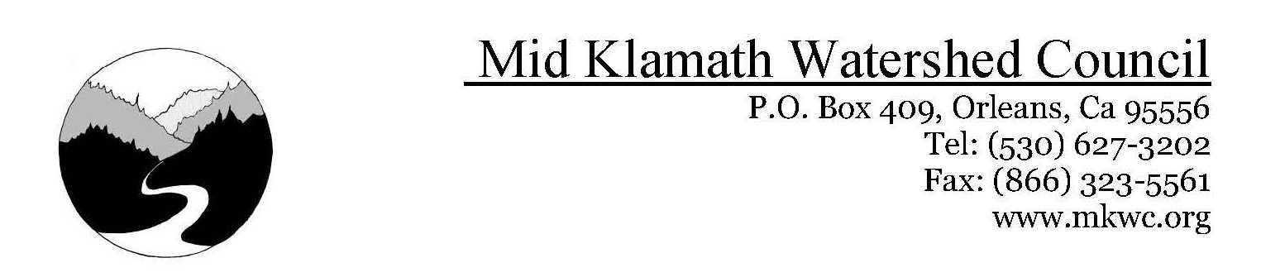

**Mid Klamath Creek Mouth Enhancement Project**

Agreement Award #F20AC00007

Sub-Contract #22-034

By: Mid Klamath Watershed Council

jimmy@mkwc.org

**Project Description**

The Mid Klamath Creek Mouth Enhancement Project is one of the Mid Klamath Watershed Councils longest running restoration projects, and has been implemented every summer for the past 13 years. This project has focused on improving access to cold water refugia for out migrating juvenile salmonids and upriver adult migrants by remediating seasonal barriers to migration and enhancing creek mouths to ease passage into important cold water habitat. The barriers encountered are typically anthropogenic, such as swimmer/mining dams, low flow barriers, and road crossings.During the summer of 2022, our survey crews assessed 41 creeks for migration barrier, and improved access to 7.75 miles of cold water habitat for anadromous fish species (Oncorhynchus spp.). MKWC identified 16 barriers, and treated 14 of the barriers that were disrupting migratory patterns or seasonal use for either adult or juvenile salmonids. These barriers consisted of swimmer’s dams, large log/debris jams, boulder/bedrock cascades, a clogged fish ladder, and low and high velocities located at the confluences of the tributaries. The untreated barriers consisted of incised three to four-foot boulder cascades (Oak Flat, Boise), and a dilapidated fish ladder (Coon Creek). Several of these barriers are encountered each year at the same sites and have limited treatment options.

**Methods**

Using a crew of field technicians, snorkel surveys were conducted on the first 1000 feet of each tributary (where appropriate) to survey for fish abundance, distribution, size, and habitat use. During these 1000 foot surveys, creeks were assessed for any barriers and were typically treated by concentrating flow, building fish step pools, or diverting water to a lower slope channel. The primary work conducted by the Fish Passage crew was site specific fish passage design and implementation. This involved manually moving boulders as well as rocks and gravel to reduce gradients, create step pools, maintain surface water connections and remove barriers to passage. Depending on the creek and time of year, we often built wing dams to consolidate flows, excavated gravels by hand to deepen the channel and focused cold water into areas of the Klamath River confluence where it would create the largest most stable thermal refuges. Our work is prioritized for juvenile Coho utilization in the spring and summer months, transitioning to adult fish passage projects in the fall and winter. Artificial barriers (i.e. swimmers dams) were also treated, as well as debris jams which can create fish impassable barriers.

Step pool construction was the most common form of creek mouth enhancement for juvenile passage while concentrating flow was the most common treatment for adult migration enhancement. Barrier identification was made using the CDFW Salmonid Stream Habitat Restoration Manual, and data for each barrier was collected during assessment, including pool depth, height of barrier, and slope. Following assessments, field crews would implement treatment by building step pools boulders to increase depth, restrict discharge, improve flow duration, and create unimpeded connections rather than sudden drops. Post work data was collected at each tributary.

**Post Work Monitoring**

MKWC monitored the success of our implementation to assess Coho, Chinook, and steelhead abundance in response to the treated barriers. Of the sites monitored, Tom Martin Creek was observed to have the highest increased salmonid density. While Coho were our target species, both Chinook and steelhead were observed in large numbers at several sites before and after treatments. Barriers can be developed through a broad range of flow conditions disrupting migratory patterns and seasonal use. With returning adult fish in the river and low flows, MKWC staff will continually monitor important tributaries for fish barriers and modify (if possible) any barriers encountered. To quantify physical and biological responses, data entry and management elements, including editing for errors, and verifying accuracy of field data is also being organized. Annual monitoring is being performed to assess Coho distribution in response to barriers.

**Results**

Much effort has been devoted to developing, constructing and refining fish passage to enable target species to pass barriers on tributaries along the Mid Klamath River basin. MKWC field crews assessed 41 tributaries, resulting in 7.75 miles of assessment of instream fish habitat and identified 16 barriers to either juvenile or adult migration. MKWC staff identified 16 barriers, of which 14 were treated for either juvenile or adult passage. Seven barriers were recently identified, mostly swimmers’ dams, and do not have post monitoring data currently. These were identified in early September. One barrier was a tributary to the Scott and due to landowner issues, MKWC was not able to conduct a monitoring assessment. MKWC documented increases of salmonid abundance in 8 of the 14 treated tributaries with identified barriers (See table 1). Of the 41 treated tributaries, over 80% of tributaries had a documented increase in salmonid presence after treatments occurred. Data gathered suggests, the effectiveness of enhancement increased fish densities in 80% of tributaries. Of barriers that had post work monitoring conducted, MKWC staff documented only one creek with a significant % increase in Coho Salmon above barriers after work was completed (2 Coho before, 50 Coho after) While Coho Salmon were our target species for this project, MKWC frequently documented Chinook and steelhead utilizing tributaries after creek mouth or barrier remediation work had occurred.

In comparison to the past few years conditions, this year was significantly different. Higher flows in the spring, coupled with rains in early July likely spurred the movement of out migrating juvenile Coho as well as other species. Temperatures in the Klamath River were also lower throughout the July period than in previous years possibly allowing fish to utilize the mainstem Klamath River for longer periods without the need to seek shelter. MKWC’s crews did not start seeing fish moving en masse into thermal refugia until mid August. A pulse flow from the Trinity River also appears to have triggered an early run of Fall Chinook. MKWC and USFS crews documented hundreds of adult Chinook and steelhead utilizing the thermal refugia at the mouth of Bluff Creek. Typically, the steep, perched creek mouth makes adult passage difficult if not impossible during these low flow periods of the year. MWKC crews conducted fish passage work on the mouth of Bluff Creek in early August to create a better passage channel and no adult fish were documented in the lower 1000 feet of the creek. The USFS conducted dives on 8/30/2022 and 800 adult steelhead and 100 adult Chinook were observed in the lower 1000 feet of Bluff Creek.

A major barrier that MKWC has documented for the past several years is the fish ladder at Coon Creek. This ladder has become severely degraded over the years and no longer functions as intended, and has structurally fallen apart where it meets the culvert under highway 96. Habitat above the ladder is fairly high-quality steelhead habitat and no adult fish have been documented above the ladder for almost a decade. This barrier is identified as Coon 1 in Figure 1.

**Outreach Activities**

During the 2022 field season, MKWC conducted 2 restoration outreach events focused on incorporating hands on restoration projects for community members. Overall, 51 individual stewards(volunteers)combined for 2 work days on 3 tributaries, and assisted in building step-pools for juvenile passage, assembling brush bundles to increase cover habitat fish utilizing thermal refugia, and created viable adult fish passageways to important spawning tributaries.

**Lessons Learned/Problems Encountered/Success Stories**

One of the biggest lessons learned from this project is how to effectively monitor creeks post treatment. With the large geographic distribution of project sites, we decided to monitor creeks that 1. Typically see natal and non-natal use by Coho, 2. Are close enough together to be able to monitor several creeks in a day 3. Complete all or most treatment work early in the season before Klamath conditions become stressful. This allowed our fisheries staff to visit more creek sites after treatment and around the time that juvenile salmonids begin seeking refuge in cold water tributaries. Even with the higher than normal flows this spring, and late summer rains, Klamath River mainstem temperatures peaked over 28 degrees Celsius and stayed in the stressful range of 23-24 degrees Celsius throughout August, which is not typical in most years. During this time MKWC staff documented high fish densities at cold water refugia’s, typically consisting of juvenile Chinook Salmon and steelhead trout, and at peak temperatures throughout August, large schools of adult Chinook and steelhead. This year we also witnessed a mass wasting event that triggered a fish kill in 50 miles of the Klamath River from Humbug Creek to Happy Camp. This was caused by intense rain being dropped on the recent McKinney Fire scar. The mud flow that occurred created anoxic conditions in this stretch of the Klamath and MKWC’s crews were unable to access over 40% of the tributaries in our treatment plan for over two weeks due to evacuation orders. When crews were able to return upriver, large amounts of suckers and juvenile steelhead mortalities were observed in the mainstem river. Klamath River clarity has still not recovered and dive counts at the creek mouths were unable to ascertain fish presence due to clarity and water quality issues.

A prime example of the importance of creek mouth enhancement project was work that was completed at Camp Creek. Along the Camp Creek delta, the creek splits into several braided channels. One of these channels empties into a large 10,000 square foot sheltered eddy in the mainstem Klamath. The braid that normally empties into this eddy provides a large thermal refugia for salmonids seeking refuge from poor mainstem conditions. This channel was naturally disconnected this year due to channel change and low flows, and MKWC crews, along with staff from the Karuk Tribe, reconnected the camp creek braid to the eddy and channeled approximately 2 CFS of cold water into the refugia. Before work was done, crews observed zero fish using the refugia eddy. After work was done, monitoring visits in late July and August documented over a 1000 fish of various salmonid species and age classes within the reconnected refugia where temperatures in the refugia were 20 degree Celsius and mainstem Klamath temperatures were 25 degrees Celsius at the time on August 7th.

|  |  |  |  |  |  |  |  |  |
| --- | --- | --- | --- | --- | --- | --- | --- | --- |
| **Tributary Name** | **Date Identified** | **Location** | **Type of Barrier** | **TreatedY/N** | **Barrier Height**  **(Before/After)** | **Dive Count Above Barrier Before Treatment** | **Dive Count After Treatment** | **Notes** |
| Aikens | 9/1/22 | N 41.22829  W123.65112 | Swimmers dam (adult) | Y | Before-1.4 feet  After- 0 feet | 0 | N/A | Not monitored after barrier work on 9/1/22 |
| Beaver | 9/6/22 | N 41.87563  W122.81982 | Swimmers dam  (adult and juvenile) | Y | Before-2.1 feet  After-0 feet | n/a | n/a | Adult monitoring will begin in October |
| Boise 1 | 8/10/22 | N 41.28266  W123.57560 | Boulder cascade | Y | Before- 2 feet  After- 1.6 feet | Coho: 0  CHK: 16  STH: 28 | Coho: 3  CHK:152  STH:262 |  |
| Boise 2 | 8/10/22 | N 41.28254  W 123.5756 | Bedrock cascade | N | 4.6 feet |  |  | cascade has been a perennial low flow barrier to juvenile fish. Not treated |
| Cade 1 | 8/2/22 | N 41.80720  W123.34896 | Bedrock cascade | Y | Before-2 feet  After-  1.8 feet | Coho: 45  CHK: 53  STH: 140 | Coho: 46  CHK:20  STH:48 | Barrier 1 and 2 are close proximity |
| Cade 2 | 8/2/22 | N 41.80720  W123.34889 | Boulder cascade | Y | Before-  1.8 feet  After-  1.5 feet | Coho: 45  CHK: 53  STH: 140 | Coho: 46  CHK:20  STH:48 | Barrier 1 and 2 are close proximity |
| Coon 1 | 8/2/22 | N 41.61291  W123.49659 | Damaged fish ladder | Y | n/a | N/A | N/A | No juvenile fish above ladder |
| Coon 2 | 8/2/22 | N 41.61316  W123.49737 | Swimmers dam | Y | Before-  1.3 feet  After-  0 feet | Coho: 0  CHK: 1  STH: 17 | Coho: 4  CHK:0  STH:30 |  |
| Elk | 9/6/22 | N 41.78047  W123.39251 | Swimmers dam | Y | Before-2.1 ft  After-  0 feet | Coho: 2  CHK: 104  STH: 486 | N/A | Identified on 9/6/2022 |
| Fort Goff | 9/6/22 | N 41.86471  W123.25805 | Swimmers dam | Y | Before- 1.9 feet  After-  0 feet | Coho: 49  CHK: 34  STH: 180 | Coho: 79  CHK:28  STH:401 |  |
| Oak Flat | 6/8/22 | N 41.72976  W123.43547 | Boulder cascade highway overpass | N | 7.5 feet | Coho: 0  CHK: 0  STH: 35 | Coho: 0  CHK:0  STH:40 | Below fish ladder in pool |
| Mill  (Scott) | 6/21/22 | N 41.74302  W123.00299 | Bedrock cascade | Y | Before-  3 feet  After-  2 feet | 33 | n/a |  |
| Portuguese | 8/11/22 | N 41.85880  W123.24595 | Swimmers dam | Y | Before-  2 feet  After-  0 feet | Coho: 5  CHK: 43  STH: 136 | Coho: 50  CHK:17  STH:136 |  |
| Rogers | 6/16/22 | N 41.444482  W123.49061 | Bedrock cascade | Y | Before-  2.6 feet  After-  0 feet | Coho: 0  CHK: 0  STH: 58 | Coho: 50  CHK:15  STH:5 |  |
| Swillup | 6/6/22 | N 41.60778  W123.50096 | Bedrock cascade | Y | Before-  2.2 feet  After-  0 feet | Coho: 52  CHK: 68  STH: 71 | Coho: 54  CHK:37  STH:154 |  |
| Tom Martin | 6/4/22 | N 41.78403  W123.04205 | Beaver Dam | Y | Before-  4.4 feet  After-  .75 feet | Coho: 2  CHK: 0  STH: 32 | Coho: 50  CHK:15  STH:5 | New channel was connected that avoids beaver dam. |

Figure 1: Barrier table data.

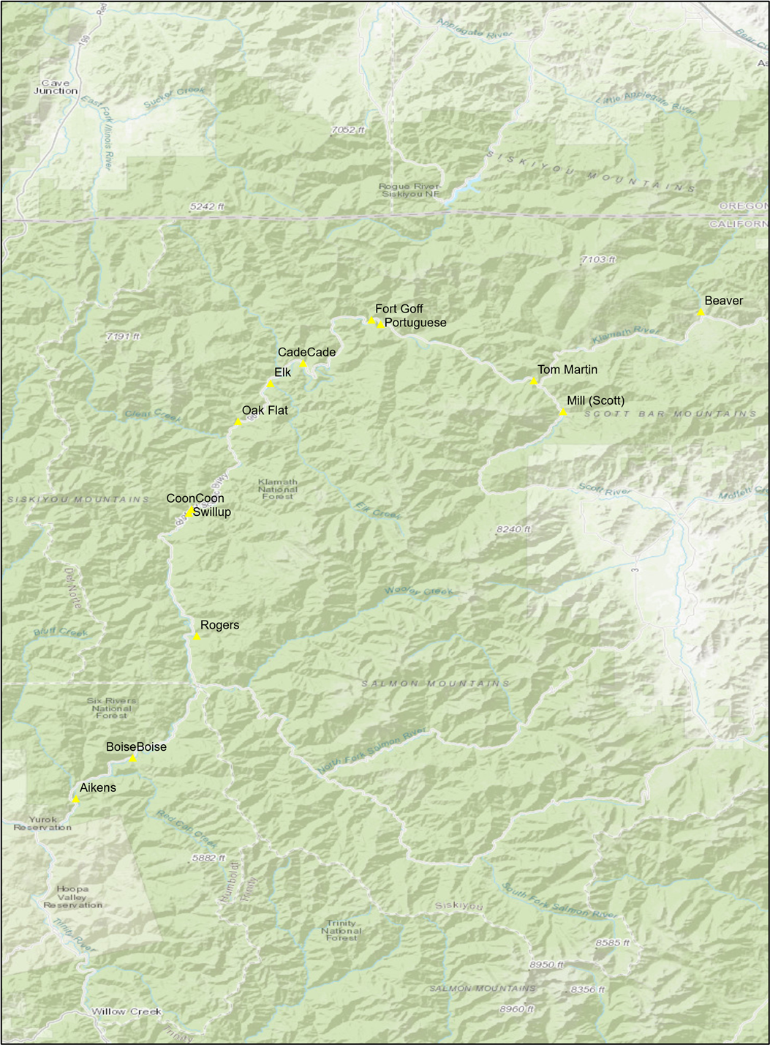

Figure 1: Map of barrier locations